Java Cell Phone Bill Lab Report

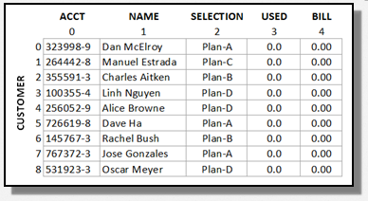
1) Enter your name, student ID, platform (Mac or PC) and date
Name and Student ID: Jibran Akhter - 1073973
Platform (Mac, PC, Linux, etc.): Windows 11 PC
Development System (NetBeans, Eclipse, etc.) onlineGDB
Date: 4/7/2024

PROJECT DESCRIPTION:
1) Complete the program to compute the cell phone bills for Plan-B, Plan-C and Plan-D
2) Display each customer bill using two lines with one digit past the decimal for the gigabytes used and two digits past the decimal for the total billed for all customers. Use a try…catch block to process any errors that occur when non-numeric data is entered for a customer's data usage.
Modify the existing JavaCellPhoneBill.java program. The code is available on the class website or:
http://program-info.net/Java/downloads/JavaCellPhoneBill/JavaCellPhoneBill.java

SAMPLE PROGRAM OUTPUT (for 3 customers)
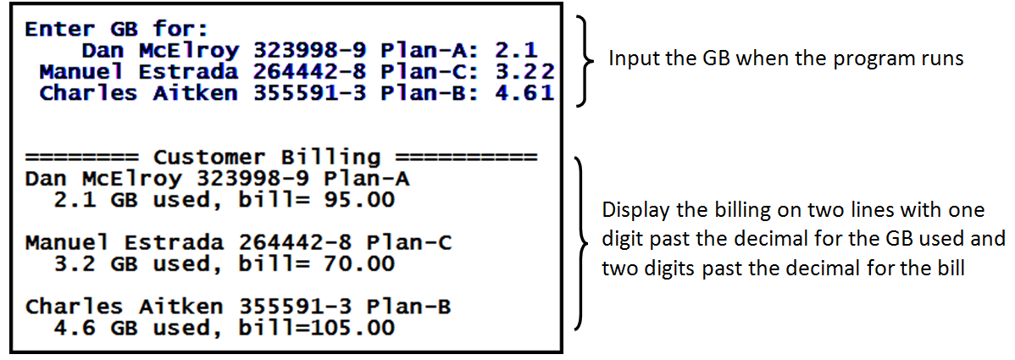

LAB REPORT:
2) Fill in the TEST VALUES & RESULTS table
Nine customers are already provided in the double-dimensional array Accounts. Add three more customers, including yourself to the table. One selection for gigabytes used must be non-numeric data.
 | Customer Name | Plan Selection | Gigabytes  Used | Expected  Bill | Actual  Bill
1 | Dan McElroy | A | 12 | $230.00 | 230.00
2 | Manuel Estrada | C | 23 | $355.00 | 355.00
3 | Charles Aitken | B | 34 | $540.00 | 540.00
4 | Linh Nguyen | D | 45 | $615.00 | 615.00
5 | Alice Browne | D | 56 | $780.00 | 780.00
6 | Dave Ha | A | 65 | $1025.00 | 1025.00
7 | Rachel Bush | B | 54 | $840.00 | 840.00
8 | Jose Gonzales | A | 43 | $695.00 | 695.00
9 | Oscar Meyer | D | 32 | $420.00 | 420.00
10 | Jibran Akhter | C | 21 | $325.00 | 325.00
11 | John Doe | A | 12 | $230.00 | 230.00
12 | Jane Smith | B | 23 | $375.00 | 375.00

DISCUSSION:
3) Complete the DISCUSSION section in English. It does not need to be long, but it needs to be complete.
3a) What did you do to develop the program?

To get started with the program, I carefully read through the project definition to understand what was needed for the cell phone billing system. Then, I dove into the provided code, looking for areas that required my attention. My main tasks included completing the billing computation for different plans and updating the printout of customer billing details. I made sure to follow the existing code structure while making these changes.

3b) What problems did you have and how did you overcome the problems?

While working on the program, I ran into an issue with handling non-numeric inputs for gigabytes used. It took some effort to figure out how to deal with this gracefully. Eventually, I decided to use try-catch blocks to detect when non-numeric data was entered. Whenever an error occurred, I added helpful error messages to guide the user in entering valid numeric data.

3c) Where in the program is the processing for illegal inputs, such as letters instead of numbers being entered for hours or pay rate?

The part of the program that deals with illegal inputs, like letters instead of numbers for gigabytes used, is located within the `billEachCustomer()` method. Here, I implemented a try-catch block to catch NumberFormatExceptions when converting the input from a string to a double. If the input isn't a valid number, the catch block sets an error flag and displays an error message to notify the user.

PROGRAM OUTPUT:
4) Provide screenshots showing correct operation of the program. Refer to previous lab assignments to review how to save a screen shot to the lab report. Adjust the size of the image on the report to show the summary information and the image of the paycheck.

